EASO’s 2020 Work Programme adopted by EASO Management Board

* 25TH SEPTEMBER 2019

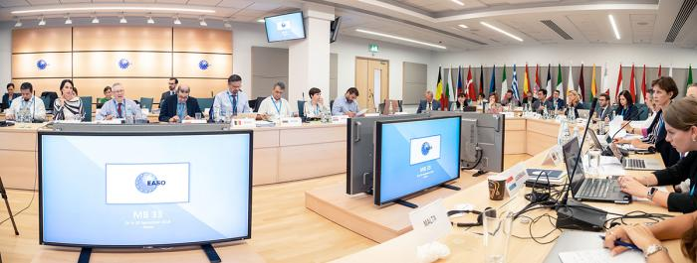

***EU+ Member States repeat recognition of turnaround in management and internal control systems.***

On **24-25 September 2019**, the **33rd meeting of the European Asylum Support Office (EASO) Management Board** was held at the Agency’s Headquarters in Malta to take stock of the latest developments in support of the implementation of the Common European Asylum System (CEAS).

The Management Board formally **adopted the Single Programming Document (SPD) 2020-2022, including the 2020 Work Programme and Budget**. This adoption paves the way for EASO to continue ramping up its already substantial support for Member States’ asylum authorities, most notably in terms of operational assistance. The adoption of the 2020 EASO Budget is subject to the overall adoption of the EU’s budget for 2020 by legislators in Brussels.

The Agency is currently providing **more operational support than ever before**and is **now active on the ground in Malta, Cyprus, Italy and Greece**, with hundreds of deployed officials, including Member State experts. EASO has also taken on a central role in coordinating the processing of individuals arriving on rescue boats in Malta and Italy over the past few months, and the relocation to Member States who have volunteered to take responsibility for their cases. This ad hoc disembarkation and relocation was discussed by a group of EU Home Affairs ministers in Malta on Monday, 23 September, and will be further discussed at the Justice and Home Affairs Council meeting in Luxembourg on 8 October.

During the meeting, Member States again also **highlighted the intensive work that EASO’s new management has taken to dramatically strengthen governance and internal control systems.** In just over a year, the Agency has already implemented 79% of its Governance Action Plan, which aims at ensuring the highest standards of good governance and financial responsibility. As part of this, an ongoing recruitment drive is underway which is enabling EASO to meet the increased requirements for its support by Member States in different areas of asylum procedures.

EASO also updated the Management Board on the **latest asylum trends in the EU+**, where to date 2019 has seen a moderate 11% increase in asylum applications, although levels remain significantly lower than during the 2015-2016 migration crisis. The Agency continues to work with national authorities to ensure resilient systems that can absorb sudden increases, and notes that a fair reform of the CEAS remains the best way to accomplish this.